TC04

**Test Scenario:** ESS User Login

**Test Case Title:** Verify login with Invalid ESS Username and Invalid Password

**Test Case Steps:** 1) Launch bowser

2) Open URL "https://opensource-demo.orangehrmlive.com/web"

3) Enter Invalid Username and Invalid Password

4) Click on Login Button

5) Document all the results you received

**Let’s add Invalid User ESS and Invalid Password as below :**

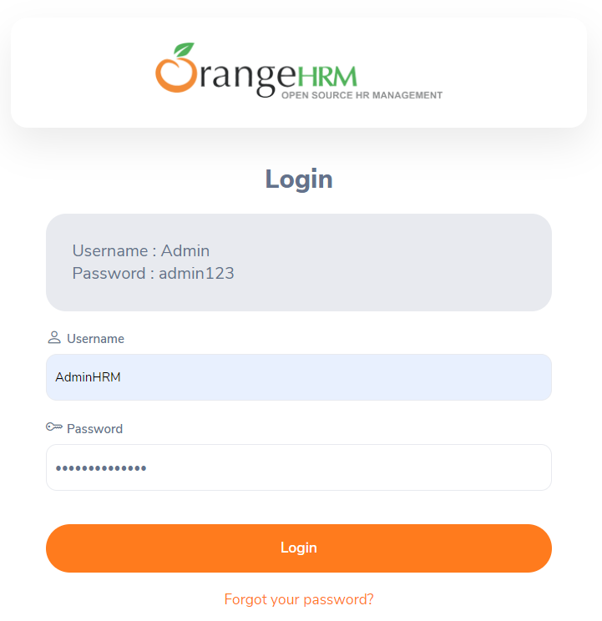

**Now click on Login Button :**

